**Introducing the Pregabalin for Whiplash Study**

**How can you help?**

You can assist by:

* Screening potentially eligible patients
* Obtaining informed consent &
* Prescribing pregabalin

OR

* Giving potential patients the Permission to Contact form &
* Contacting the study team.

**Who is ELIGIBLE?**

* Individuals with Grade II Whiplash Associated Disorder
* Within 48 hours of injury
* Experiencing at least moderate pain

on arrival in ED (VAS: ≥ 5/10)

* Aged 18-65 years.

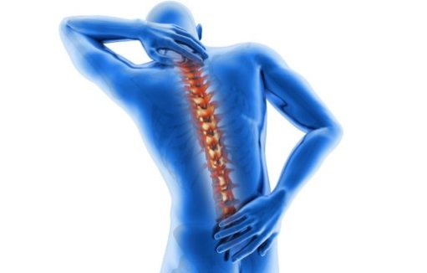

**Who CANNOT participate?**

* Known or suspected serious spinal pathology (e.g. metastatic disease of the spine)
* Confirmed fracture or dislocation at time of injury (WAD IV)
* WAD III (neurological compromise eg decreased reflexes, muscle power)
* Previous whiplash injury or neck pain condition requiring treatment
* Patients using gabapentin/pregabalin
* Patients with known peripheral neuropathy
* Known hypersensitivity to pregabalin use (hives, blisters, rash, dyspnea and wheezing)
* History of renal insufficiency
* Women who are pregnant or breastfeeding
* History of psychiatric illness or substance abuse
* Inability to speak and write in English (participants will be required to complete questionnaires written in English only).

**Ethics approvals:**

GCUH HREC/16/QGC/296

Griffith University

**What is the pregabalin for whiplash trial?**

The **primary aim** of this study is to conduct a randomised controlled trial examining the effectiveness of pregabalin to prevent chronic pain following whiplash injury in ‘at-risk’ individuals.

**Secondary aims** are to:

1) Investigate the effectiveness of pregabalin to decrease disability, depression, posttraumatic stress symptoms, pain catastrophizing and

2) To conduct an economic evaluation of the pregabalin intervention.

**For more information, please contact:**

Professor Michele Sterling   
Ph:  [0488 196 862](tel:%2B61%20488%20196%20862)  
E: [m.sterling@uq.edu.au](mailto:m.sterling@uq.edu.au)

Dr Jane Nikles

Ph: 0408 599 033

E: [uqjnikle@uq.edu.au](mailto:uqjnikle@uq.edu.au)



**NHMRC CENTRE OF**

**RESEARCH EXCELLENCE**

**IN RECOVERY FOLLOWING**

**ROAD TRAFFIC INJURIES**