

For further information:

**Email:** [**uqjnikle@uq.edu.au**](mailto:uqjnikle@uq.edu.au)

**OR**

[**sherin.jacob@uq.edu.au**](mailto:sherin.jacob@uq.edu.au)

RECOVER Injury Research Centre

The University of Queensland

Level 7, UQ Oral Health Centre

Herston, QLD

4006, Australia

Phone: 0408 599 033

Website: [recover.centre.uq.edu.au](http://recover.centre.uq.edu.au)

acute

Whiplash

**WHIPLASH**

Whiplash is a common term for sudden acceleration-deceleration forces on the neck as a result of rear-end or side-impact motor vehicle collisions, driving accidents, and/or other mishaps. Whiplash can be a debilitating injury that is financially, physically, and psychologically costly.

Whilst most healing occurs in the first 2-3 months:

> Up to 50% will never fully recover

> 30% will remain moderately disabled by their condition.

**WHO ARE WE?**

The RECOVER Injury Research Centre is a joint initiative of the Queensland Motor Accident Insurance Commission (MAIC) and The University of Queensland.

The mission of RECOVER is to produce breakthrough research, which leads to better outcomes after injury, especially when caused by road traffic crashes.

It is only through ongoing research that it will be possible to develop more effective treatments to lessen the physical and psychological suffering that can arise following injury.

This project has been granted clearance from The University of Queensland Human Research Ethics Committee and Darling Downs Hospital and Health Service Human Research Ethics Committee.

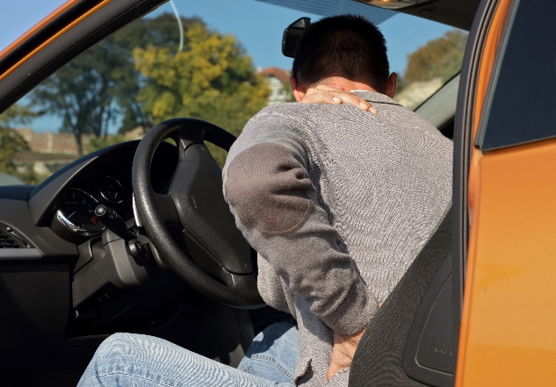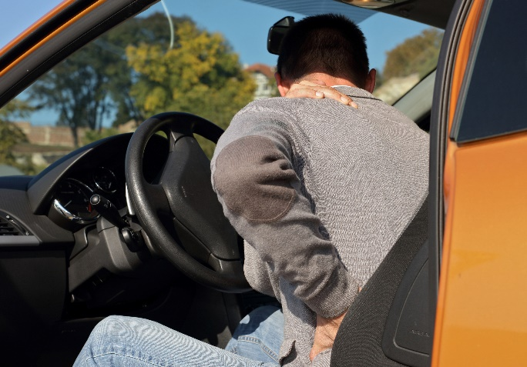

We are looking for individuals who have had a whiplash injury in the last 2 weeks and still have neck pain.

If you are interested in taking part in the study, please contact the research team at

[**uqjnikle@uq.edu.au**](mailto:uqjnikle@uq.edu.au)

OR

[**sherin.jacob@uq.edu.au**](mailto:sherin.jacob@uq.edu.au)

or phone **(04) 0859 9033**

to confirm your eligibility.

This study will compare the effectiveness of paracetamol (Panadol), naproxen (an anti-inflammatory medicine), and both paracetamol and naproxen together, for treating acute whiplash pain and for preventing chronic pain from whiplash.

WHAT IS involved?

You will be asked to complete questionnaires and fill out a journal for the length of the study.

**What are the benefits for me?**

You will be given a booklet containing exercises and advice on how to manage your pain that you can use throughout. After consultation with our trial GP, you will receive a personalised medication report at the end of the trial, detailing which treatment works best for you.

WHAT IS THE

STUDY ABOUT?

Who is eligible?